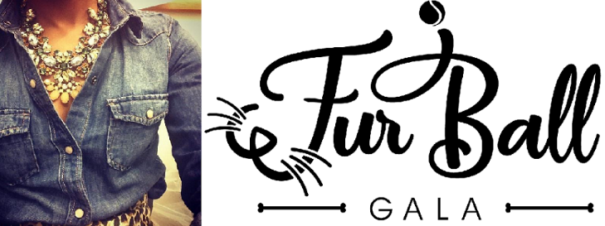
Denim & Diamonds
Cause for Paws
Saturday, March 14, 2020
The Medallion Country Club, Westerville

Dear Friends

Please support The Humane Society of Delaware County by donating to The Fur Ball Gala auction. This event not only supports The Humane Society of Delaware County, but it also allows you to promote your organization/business to the thousands of Central Ohio residents who walk through our shelter, receive our newsletters, visit or Facebook page, receive our emails, visit our website AND take part in this fundraiser.

The Fur Ball Gala “Denim & Diamonds – Cause for Paws” is March 14, 2020 at The Medallion Country Club, in Westerville. 300 people will be on-hand to view your donation, with 1,000’s more aware of your business through ongoing promotion leading up to the event.

The Fur Ball Gala promotions begin January 2020. We want to confirm your auction donation at your earliest convenience, so your business’ name can be included in the most promotion possible.

A complete basket/large item or even a gift card from your business is appreciated. Questions? Please contact Jane Nolan, jane.nolan@hsdcohio.org

Thank you so much for your support!

Jane Nolan
Events and Development Manager
The Humane Society of Delaware County

The Humane Society of Delaware County operates on a
monthly deficit of $15,000. Our clinic and adoption fees do not
begin to cover all the costs of caring for each animal.

We are a non-profit 501(c)(3), and do not receive
any of your tax dollars. When you donate to The Fur Ball Gala,
you help us find homes and provide care for animals in need!
For donations purposes our tax ID #31-0956920

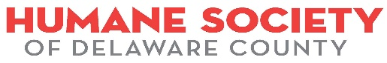
4920 St. Rt. 37 East, Delaware, OH 740-369-7387 HSDCOHIO.ORG

